**ULTRASONIC SENSOR**

#define TRIG 10

#define ECHO 11

long duration,distance;

const int LED = 1;

void setup() {

// put your setup code here, to run once:

Serial.begin(9600);

pinMode(LED,OUTPUT);

pinMode(TRIG,OUTPUT);

pinMode(ECHO,INPUT);

}

void loop() {

// put your main code here, to run repeatedly:

digitalWrite(TRIG,LOW);

delayMicroseconds(2);

digitalWrite(TRIG,HIGH);

duration = pulseIn(ECHO,HIGH);

// delayMicroseconds(10);

distance = (duration/2)/(29.1);

if(distance < 50)

{

digitalWrite(LED,LOW);

}

digitalWrite(TRIG,LOW);

Serial.println(distance);

}

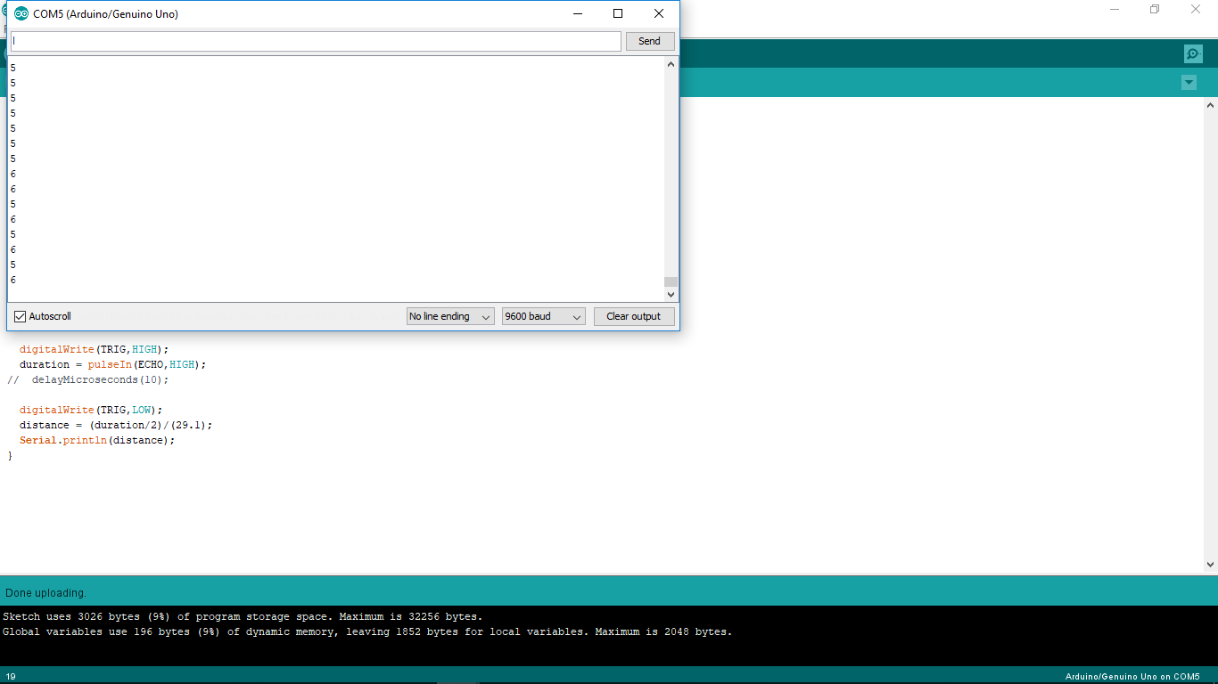

**7 Segment PART 2**

#define TRIG 10

#define ECHO 11

long duration,distance;

const int LED = 8;

void setup() {

// put your setup code here, to run once:

Serial.begin(9600);

pinMode(LED,OUTPUT);

pinMode(TRIG,OUTPUT);

pinMode(ECHO,INPUT);

}

void loop() {

// put your main code here, to run repeatedly:

digitalWrite(TRIG,LOW);

delayMicroseconds(2);

digitalWrite(TRIG,HIGH);

duration = pulseIn(ECHO,HIGH);

// delayMicroseconds(10);

distance = (duration/2)/(29.1);

if(distance < 50)

{

digitalWrite(LED,LOW);

}

else{

digitalWrite(LED,HIGH);

}

digitalWrite(TRIG,LOW);

Serial.println(distance);

}